SPH IP Tracking
Business Requirements and Functional Specifications

Version 1.0
Nov 7, 2008


Author Information
Name: | Lun Zhong
Title: | Technical Architect
Email: | Lun.Zhong@fastsearch.com
Notes:

Revision History
Version | Author | Changes
1.0 | Lun Zhong | First version
User Sign-off
The Specifications herein serves to document clearly and completely all the requirements as specified by the User for this system development. The User, represented by the undersigns below, confirms that the User has reviewed this Specifications.

Any changes required thereafter shall be subject to subsequent mutual agreement by appointed representatives of both the User and ITD.

ITD
Supported by: |  | Approved by:
Signature / Date |  | Signature / Date
Ben Lim |  | Liang Moung
Name |  | Name
Project Manager |  | Vice President, Applications
Designation |  | Designation

IBU

Supported by:
Signature / Date
Sebastian Chow
Name
Senior Manager
Designation
Approved by:
Signature / Date
James Heng
Name
Executive Vice President
Designation
Table of Contents
1. Project Overview 6
1.1 Target Audience 7
1.2 Solution Overview 7
2. Definitions 8
3. Assumptions, Dependencies, Constraints 9
4. Requirement Specification 10
4.0 Infrastructure 10
4.0.1 Overview 11
4.0.2 Assumptions 11
4.1 Login 11
4.2 Crawling 12
4.2.1 Overview 12
4.2.2 Assumption 12
4.2.3 Requirement 13
4.3 Indexing 13
4.3.1 Overview 13
4.3.2 Assumption 13
4.3.3 Requirement 13
4.4 Suspected Content & Infringement 14
4.4.1 Overview 14
4.4.2 Assumption 14
4.4.3 Requirement 14
4.5 Case Log 15
4.5.1 Overview 15
4.5.2 Assumption 15
4.5.3 Requirement 15
4.6 Report 17
4.6.1 Overview 17
4.6.2 Assumption 17
4.6.3 Requirement 17
4.7 Site Info 19
4.7.1 Overview 19
4.7.2 Assumption 19
4.7.3 Requirement 19
4.8 Settings 21
4.8.1 Overview 21
4.8.2 Assumption 21
4.8.3 Requirement 21
5. Screens 22
5.1 Login 22
5.2 Suspected Content & Infringement 23
5.3 Case Log 23
5.4 Report 23
5.5 Site Info 23
5.6 Settings 23
6. Reference 23

Project Overview
The problem of intellectual property protection has been gaining importance in the last decade. According to research finding, for the publishing industries alone, the loss to copyright piracy was estimated at $1 billion or more in 2006.
To protect SPH businesses and content from online piracy, SPH ITD has advocated for FAST IP tracking solution which help to combat misuse of SPH intellectual property by third parties. The objective is to identify and log SPH text content on the Internet. It should also provide general infringement reports and tools for SPH staff to investigate infringement.
The software components of FAST IP Tracking are:
- Script to import Singapore company information from reliable sources like SPH search and others.
The script reads the company URLs from the source and ingests into the database

- Script to generate crawler configuration
The script reads the company URLs from database and creates Fast Enterprise Crawler configuration in XML format. The company URLs will be used as a seed list for web crawling and the number of levels/depth of the crawl can be configured.

- Front-End Application consists of the following modules:
  - Suspected and Infringement Content – allows user to check and validate infringements discovered from the crawling cycle.
  - Case Log – allows user to manage cases for different URLs
  - Reports – provide different statistic from the crawling cycles
  - Site Info – allows user to maintain and manage URLs and company information
  - Setting – allows user to make adjustment to the default parameters and values.

- ESP Customization
The customization includes all necessary configuration, scripts and codes for ESP backend components, such as crawler and document pipelines.

The following are 2 key inputs required by the IP tracking system:
- The company URLs Seed List
- The content from SPH Newslink 2.0.

Target Audience
The purpose of this document is to serve as the high level requirement specification and is intended to be for use by end users and engineers who will be maintaining and supporting the system.

Solution Overview
The Fast IP Tracking Solution comprises of 2 main components:
- Back end component which will handle the content mapping and matching in order to identify suspected infringements.
- Front end component which facilitates the users in investigating and managing infringement cases.

Definitions
Term | Definition
ESP | Fast Enterprise Search Platform
Crawler | A Fast content connector that retrieves external web content.By following links, a crawler is able to traverse Web content hierarchies based on a single start URL.
URL/URI | URI is overall namespace for identifying resources.  URL is a specific type that includes the location of resource.  URI is a more general term and is preferred. Refer to RFC 3986 on http://www.ietf.org for more details.
Web Page | A web page is the standard unit of content returned by a web server.
Content | A general term for data that is submitted from different data sources and flows through ESP  Content undergoes different steps of document processing and indexing before it is available for searching.
Document | A searchable entity in Fast index
Document Processing Engine, Pipeline and Stage | Document processing engine is one ESP software component that consists of multiple document processing pipelines. Any incoming document is sent through a specified document processing pipeline.  Document processing pipelines consist of multiple document processing stages. These document processing stages read element values of the document to be processed, compute analyses on them, and modify or add elements to the document.
Newslink | An ESP index repository that stores SPH archived content which includes text articles, PDFs and images.
Suspected Content | A web page that contains similar content on Newslink is considered a suspected content.  The similarity of the content will be determined by IP Tracking internal algorithm.
Infringement | After a user confirms suspected content it will be treated as infringement and used as evidence to log a case. The company that publishes the infringement will be subject to pay a charge.
Case | For each crawling cycle, all Infringements found for a company forms a Case.  For a particular case, SPH will issue a letter (friendly or infringement) to the company.

Assumptions, Dependencies, Constraints

The Back end engine of the Fast IP Tracking solution will be developed and deployed on ESP 5.2 on Sparc Solaris 10. Fast IP tracking can co-exist and access the content in Newslink which is currently deployed on ESP 5.1 on Spac Solaris 10. However, we shall upgrade to ESP 5.2 for Newslink 2.0.

The following is in the current scope and will be implemented within this project cycle.
- Fast IP Tracking will crawl local “Singapore” company web sites.
- Fast IP Tracking will crawl local English content web sites.
- Each web page will be considered and compared as only one article.

The following is currently out of scope but can be implemented in future enhancements.
- Photos or pictures can be tracked using watermarking technology.
- Fast IP Tracking can be improved to work on other languages such as Chinese and etc.
- It can also be tuned to suit the following exceptional cases:
  - Multiple infringing articles on one web page
  - One infringing article across multiple web pages
  - A small infringing article in one big web page

Requirement Specification

Infrastructure

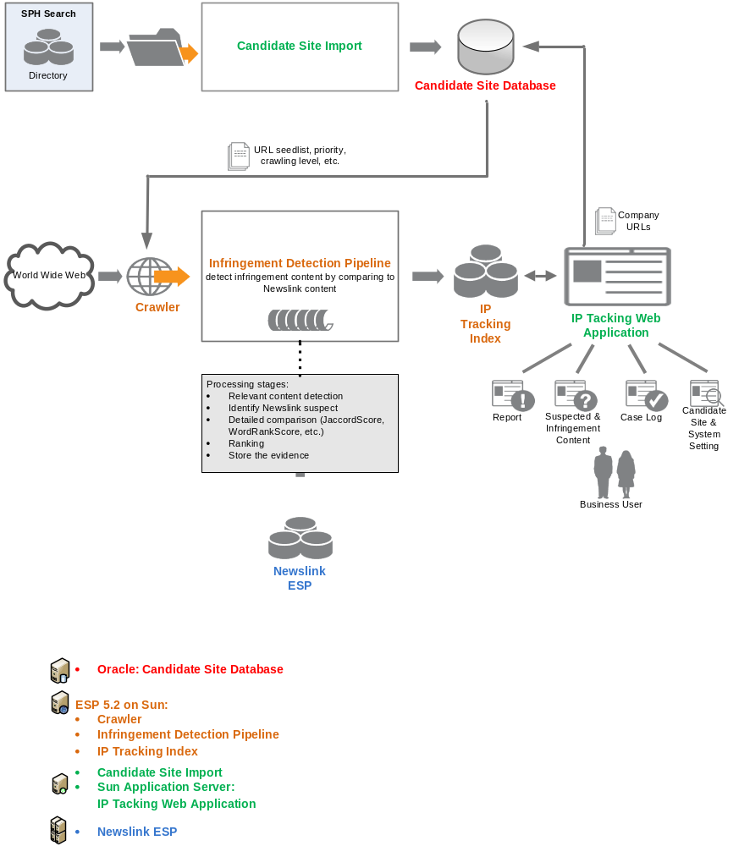

Overview
The infrastructure above depicts the overall architecture of the IP Tracking System. It comprises of the following key components:
- Candidate site database contains the local company URLs
- WWW – the WWW is the source for IP tracking crawler to look out for infringements
- ESP “Newslink” - the IP Tracking back end engine will access the content on Newslink 2.0 for matching and mapping
- ESP Crawler is the engine that crawls websites
- IP Tracking Web Application - enables the end user to administer the IP Tracking system.

Assumptions
SPH will provide local company information including the following fields:
- Web Site
- Company Name
- Registration ID (optional)
- Address (optional)
- Telephone (optional)
- Email (optional)

There will be no access control (authorization) built into the application. User accounts will be created on application server. Once the user login successfully; he/she can access all functions on the Front-end application.

Login
The login is base on system level authentication i.e. users’ ID will be created at application server. Once the user login to the system, he or she can access all functionalities on the system.

Screen 5.1
Req# | Requirement Description | Priority
1.1 | Support user authentication at system level | Must

Crawling

Overview
This is the process where the FAST crawler will browse the WWW automatically in a methodical manner taking inputs from the local company seed list to detect potential infringers.
- Crawling cycle – can be triggered at the front end application or manually at the back end application.
- When a new crawling cycle kicks start, it will clear crawler work queue and unfinished downloading.
- New company URLs can be added into the existing seed list during a crawling process.
- The crawler will not need to crawl on the infringing URLs at the next crawling cycle.

Assumption
Crawling policies – The crawling policies will be base on default setting for all websites for a start. The following are some crawler behaviors the administrator can set after the system is stable to ensure effective crawling:
- A selection policy that states which pages to download.
- A re-visit policy that states when to check for changes to the pages.
- A politeness policy that states how to avoid overloading websites.
- A parallelization policy that states how to coordinate distributed web crawlers.

For current scope, the crawler
- Will crawl the public websites based on the seed list provided.
- Only text content is fetched excluding images, audio, video, flash, files etc.
- The crawler will not crawl on the secured sites which requires login.
- The crawler can be set to crawl on the number of levels or depth on all websites.

Requirement
Req# | Requirement Description | Priority
2.1 | Startup/Pause & Shutdown the crawler | Must
2.2 | Insert the site info from source company URL listing into database | Must
2.3 | Crawling configuration generated from database:  - Start URLs  - Start URL Priority (Urgent/High/Medium(default)/Low)  - Level (default: 4)  - etc. | Must
2.4 | Delete or add web sites at run time (during the crawling cycle) | Must
2.5 | Crawling cycle statistics | Must
2.6 | Relevant Content Detection: remove the “noisy” content, such as banner, navigation, etc. | Optional

Indexing

Overview
The crawler will feed the web content to ESP document processing pipeline. In the pipeline, the system will try to find “similar” content from Newslink. If it is found, a more detail matching will follow in order to confirm that the content is a “near-duplicate content”. It will also determine the percentage of match.

Assumption
Each web page will be considered as one article.
Newslink 2.0 index setting will support IP Tracking algorithm requirement.

Requirement
Req# | Requirement Description | Priority
3.1 | Content input:  - Suspected content crawled and downloaded from public web sites  - Search will still be available while indexing | Must
3.2 | Update Index: at every crawling cycle | Must
3.3 | Suspected Content Detection:  - Content mapping with Newslink ESP index  - Detail Content matching to be specified by % | Must

Suspected Content & Infringement

Overview
User can view the suspected content discovered by current crawling cycle then compare with the content on Newslink 2.0 side by side. The user can then do a screen-capture of the source page as evidence and log a case on the infringement.

Assumption
In order to confirm infringement, the user has to refer to an external system to validate whether the company has subscribed to a package for hosting the content.
The user also has to capture the source page as JPG with 3rd party software, resize properly and upload the JPG to system.

Requirement
Screen 5.2
Req# | Requirement Description | Priority
4.1 | Conduct search on suspected content by:  - Site Info (Web Site or Company Name)  - Publication  - Article Headline  - Status  Order by:  - Web Site  - Company Name  - Publication  - Article Headline  - Match% | Must
4.2 | Result:  - Web Site  - Company Name  - Publication  - Article Headline  - Source URL  - Match%  - Status: new(default), infringement, non-infringement, uncertain | Must
4.3 | Infringement Validation:  - Pop up both suspected content and Newslink content side by side  - Provide the following buttons: uncertain, infringement, non-infringement, Source Site, Cached HTML, upload evidence  - Allow user to upload the screen capture JPG as evidence  - Once confirmed, the infringement is linked to a case  - User can update the status, i.e. infringement -> non-infringement and vice versa. | Must

Case Log

Overview
At each crawling cycle, after the user has confirmed an infringement, a case will be created for the candidate site with confirmed infringements. After a letter is sent, the user should update the case with a status specifying the date the letter was sent. If the company did not follow up with a settlement amount payment within 1 month , the case will be categorised under Review status. A case can be closed as either paid or discharged base on user discretion.
When there’s a non-close case, the related site will be excluded from the next crawling cycle (active=false). When the case is close (Paid or Discharged), the site will then be enabled for crawling again.

Assumption
N/A

Requirement
Screen 5.3
Req# | Requirement Description | Priority
5.1 | - Select case by:Crawl cycle and Date of Crawl  - Case ID  - Site Info (Web Site or Company Name)  - Status: 0New, 1Pending, 2Review, 3Paid, 3Discharged  - Next Review Date (From: date To: date)  Order by:  - Crawl cycle and Date of Crawl  - Web Site  - Company Name  - Status  - Next Review Date | Must
5.2 | Result:  - Crawl cycle and Date of Crawl  - Case ID  - Web Site  - Company Name  - Status  - Next Review Date | Must
5.3 | Create & Edit Case Screen 5.4 :  - Case ID (system generated)  - Web Site  - Company name  - Creation Date  - Last Updated  - Chargeable Amount$  - Review Date Updated On  - Settlement Amount$  - Settlement Date  - Status  - New Review Date  - Remarks  Evidence List:  - Publication  - Publication Date  - Article Headline  - Source URL  - Newslink URL  - Match%  - Evidence JPG  Upload Evidence:  - Publication Code  - Publication Date  - Article Headline  - Evidence JPG | Must
5.5 | Print & Save:  - Edit & save the letter  - Display Domain Info  - Display all evidences (Article Running No., Publication, Publication Date and JPG) | Must

Report

Overview
User can view the statistics by crawling cycle, publication and case.

Assumption
N/A

Requirement
Screen 5.4
Req# | Requirement Description | Priority
6.1 | Statistics base on Crawl Date Time  - Web Site# (High# Medium# Low#)  - Company#  - Suspect#  - Infringement#  - Case#  - Craw Date Time  - Crawl status (Success, Failed)  - Feeding status of seed list  - Progress%  - Active Sites#  - Downloaded URIs#  - Document# (current/avg/total)  - Document Size (avg/max)  - Bandwidth (current/avg/total)  Order by:  - Crawl Date Time | Must
6.2 | Statistics by publication:  - Crawl Date Time  - Publication  Results  - Pub  - No of Infringements  - Total Chargeable Amount$  - Total Settlement Amount$  - Total Discharged Amount$  - Average Settlement Time  - No of Suspects  - No of Cases  Order by:  - Crawl Date Time  - Publication | Must
6.3 | Statistics by case:  - Crawl Date TimeNo. of Cases (New# Pending# Review# Paid# Discharged#)  - No. of Paid Cases  - No. of Discharged Cases  - No. of Cases under Review Status  - Total Chargeable Amount$  - Total Settlement Amount$  - Total Discharge$  - Total Paid$  - Average Turnover Time  Order by:  - Crawl Date Time | Must

Site Info

Overview
The user interface for candidate site info allows users to upload a seed list or maintain the list manually.

Assumption
SPH Search will provide a list of local companies for us to start with. Subsequently, SPH admin users will maintain as required.

Requirement
Screen 5.5
Req# | Requirement Description | Priority
7.1 | Search candidate site by:  - Site Info (Web Site or Company Name)  - Active (Y, N)  - Crawl Priority (High, Medium, Low)  - Current Case Statue: 0New, 1Pending, 2Review, 3Paid, 4Dischaged  - Next Review Date  Order by:  - Web Site  - Company Name  - Crawling Priority  - Current Case Status  - Next Review Date | Must
7.2 | Result:  - Web Site  - Company Name  - Active: Yes/No  - Crawl Priority (High/Medium(default)/Low)  - Current Case id (Total Case#)  - Current Case Status (Next Review Date)  - Current Chargeable Amount$ (Total$)  - Current Settlement Amount$ (Total$)  - Current Discharge$ (Total$)  - Average Turnover Time | Must
7.3 | Create/Edit/Delete Site Info:  - Web Site  - Company Name  - Active: Y/N  - Crawl Priority (High/Medium(default)/Low)  - Urgent (default unchecked)  - Domain Ownership Information  - Singapore Business Registration ID  - Address  - Contact No.  - Email  - Effective Package  - Effective Period  - Remark  - Total Case #  - Case List (Case ID, Crawl Date Time, Status) | Must

Settings

Overview
This interface allows users to start, stop the crawler and configure some parameters on the system. The initial configuration should be done together with ITD technical support team unless the user is very confident on how to set these configurations.

Assumption
N/A

Requirement
Screens 5.6
Req# | Requirement Description | Priority
8.1 | - Start Crawl  - Pause crawling  - Resume crawling  - Update crawler configuration | Must
8.2 | - Upload friendly letter template  - Upload infringement letter template | Must
8.3 | - Investigation fee per case  - Infringement Fee per article  - GST% | Must
8.4 | - Case Review Period | Must

Screens

The following screens and flow are samples for design purpose. Changes may be made during design phase.

Login
Login screen
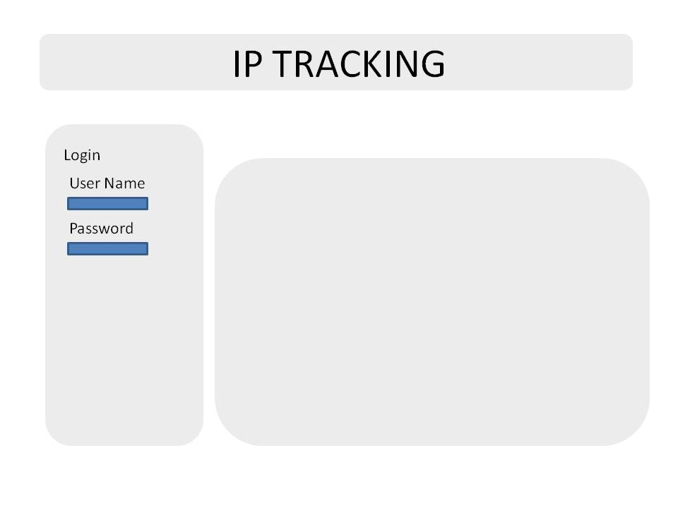

Suspected Content & Infringement
Search suspect and Infringement Screen
- A list of suspected sites, if any, will be listed according to user input and selection e.g. publication and suspect status.
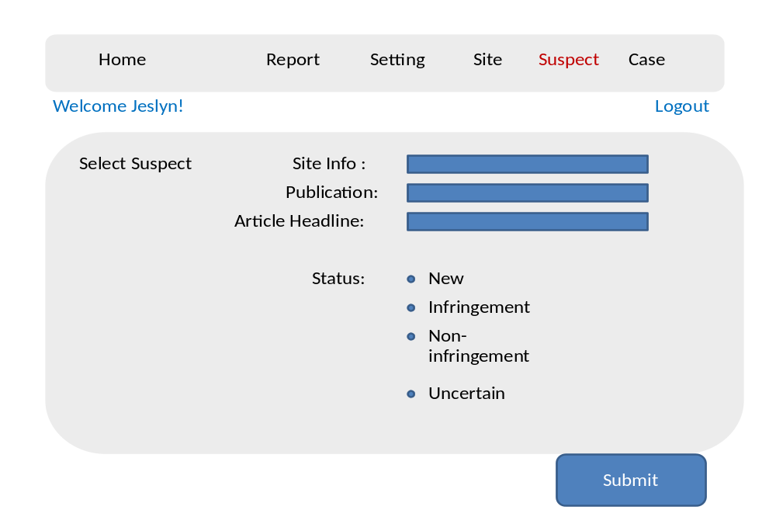
Suspect and Infringement Results
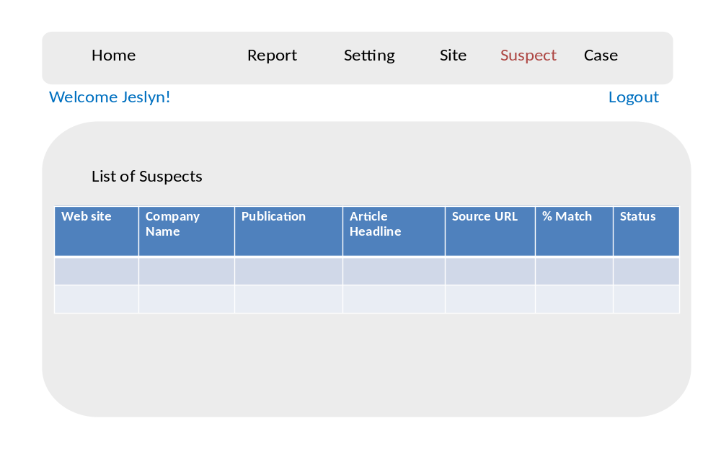
Verify Suspect Screen
- Click the ‘Article Headline’ in the above suspects table to view the infringement comparison of the suspected article and the original article.

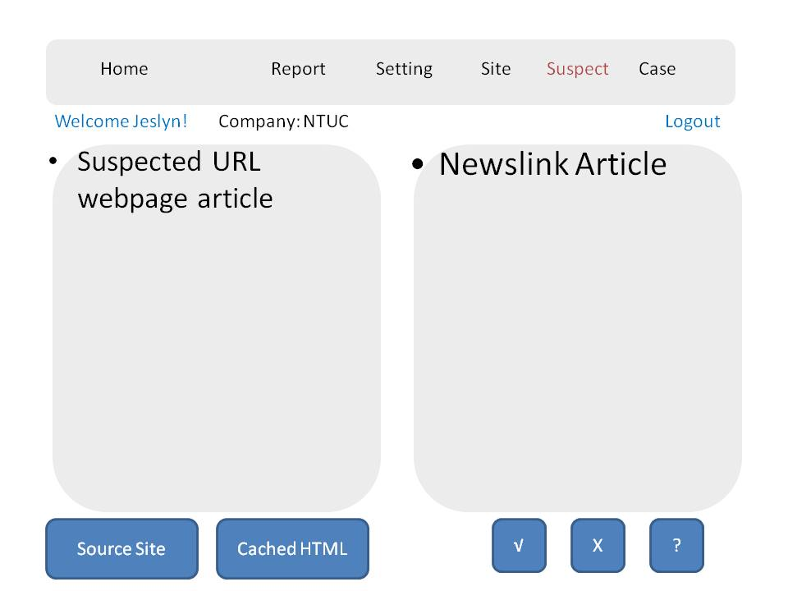

- Click the ‘Source Site’ button above to open the infringement source page.
User needs to use software such as ‘SnagIt’ to capture and save the infringement image as evidence or proof.
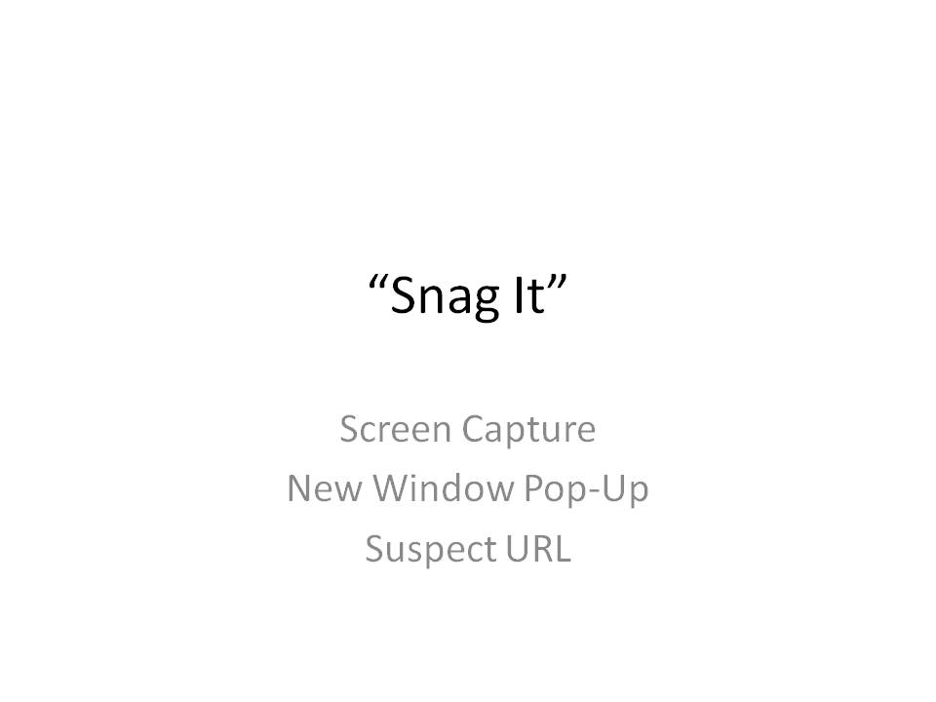

Upload Evidence Capture Screen
- Click the tick button from the screen of the infringement comparison to upload the image to system, which is shown below
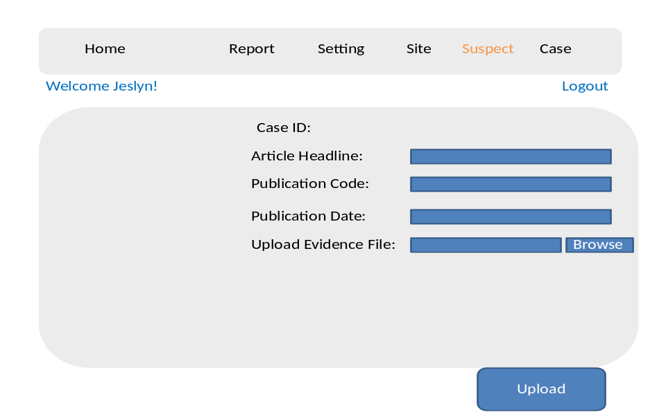
- Click the ‘Upload’ button to save an evidence image to system. A case will be created when an image is uploaded.

Case Log
Search and Manage Case Screen
- Click the ‘Case’ button to view or search a case for information. 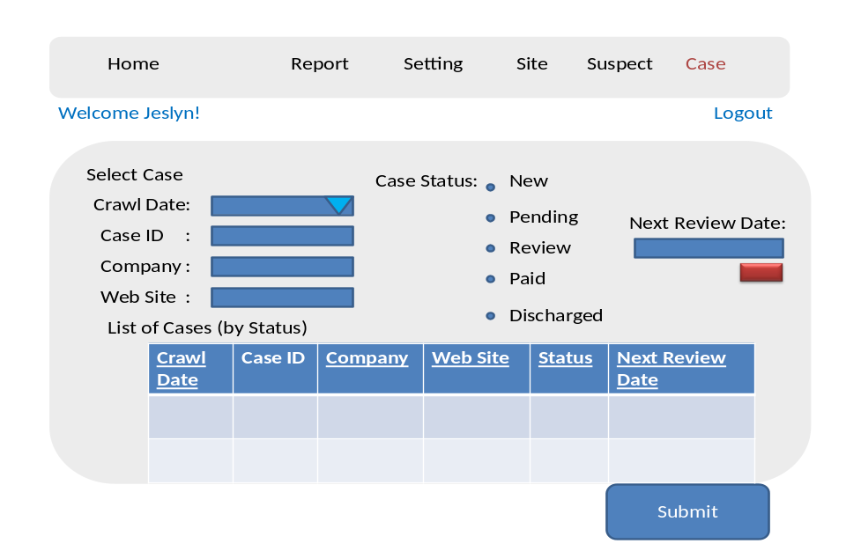
- Click button ‘Submit’ to view the case filter results
- Click on a case listed above to manage a case.
Create, Edit and delete Case Screen
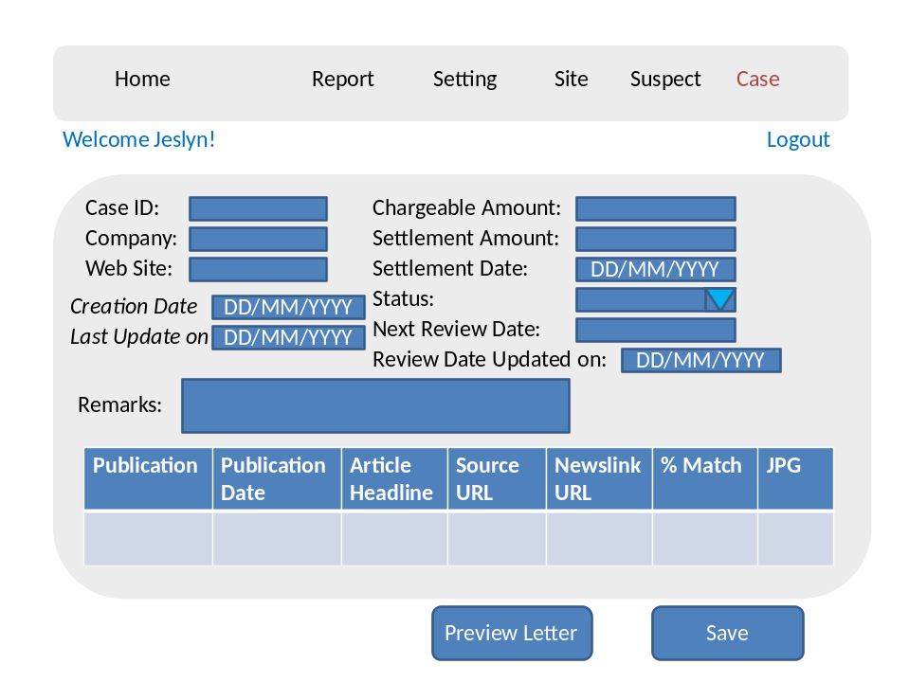
- Press the ‘Save’ button to save the case information or press the button ‘Preview Letter’ to view and edit the sample of infringement letter shown below.
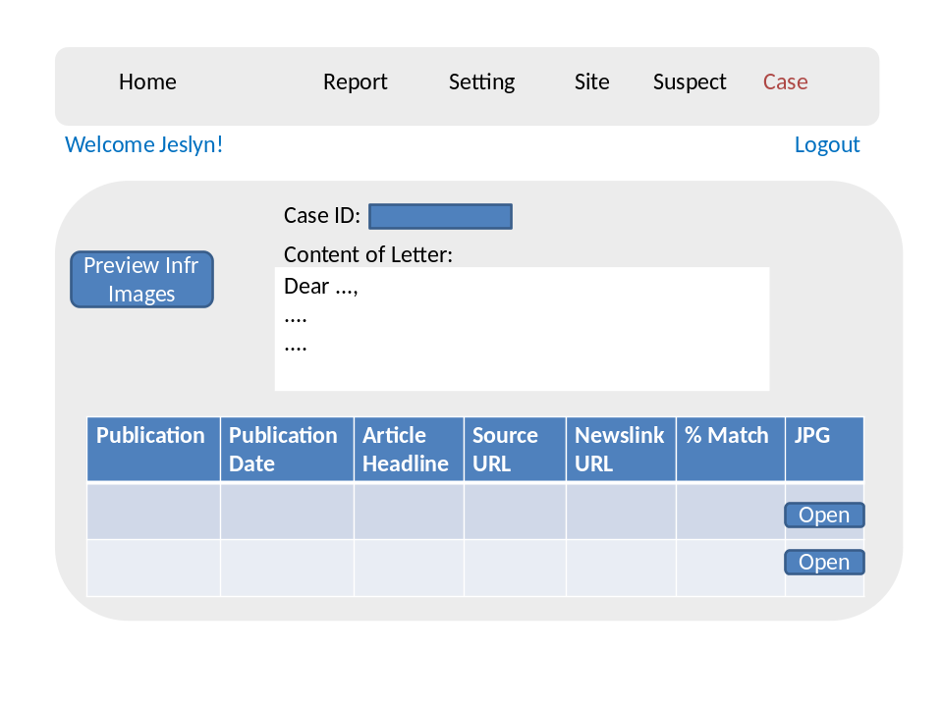
- Press the button ‘Open’ above to view the infringement image 1 by 1
- Press the button ‘Preview Infr Images’ above to preview all infringement images and domain information. Please refer to results screen below
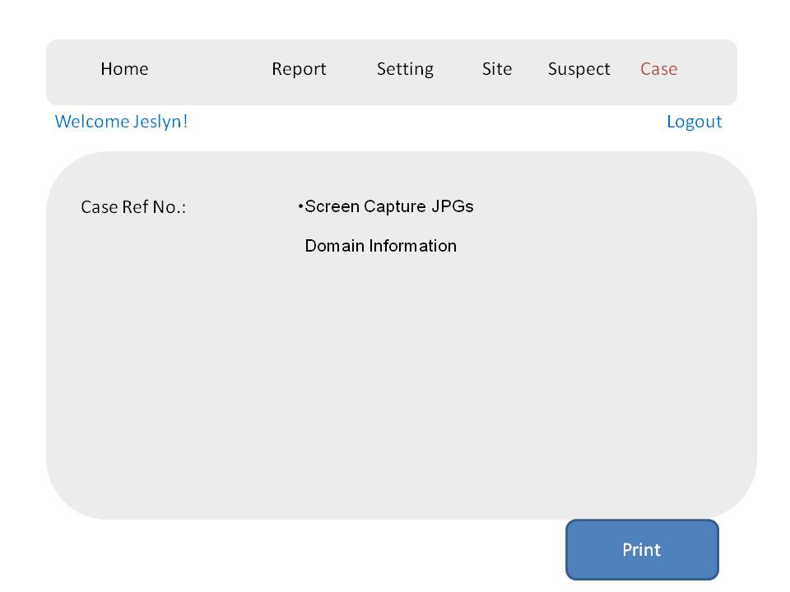
- Press ‘Print’ button to print out the list of the infringement images and domain information.

Report

- Click the button ‘Report’ on the menu to view the various reports:
- Crawl cycle summary statistics
- Publication summary statistics
- Case summary statistics

- Crawler Summary Statistics is shown below.
- Select a specific crawled schedule to view a summary report.
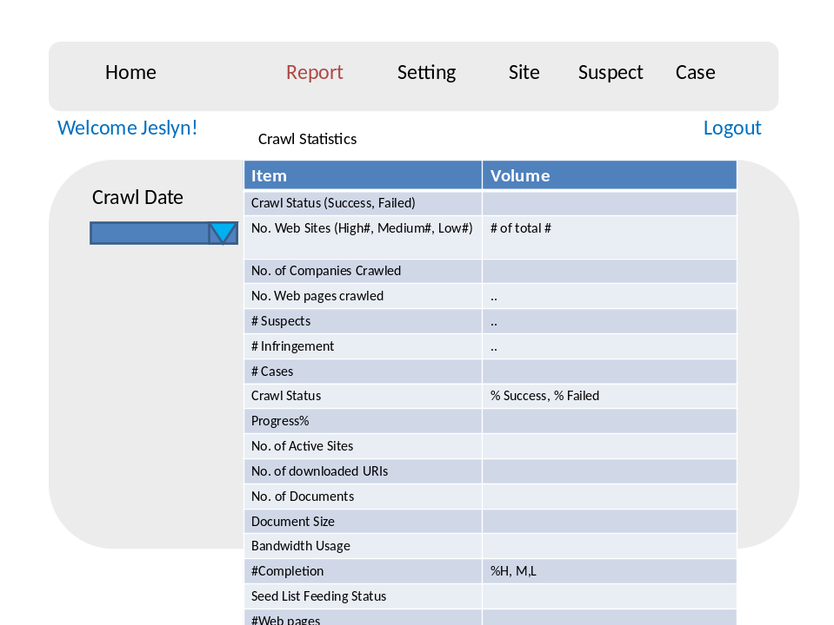

- Publication summary statistics is shown below.
- Select a specific publication code and crawled schedule to view a report
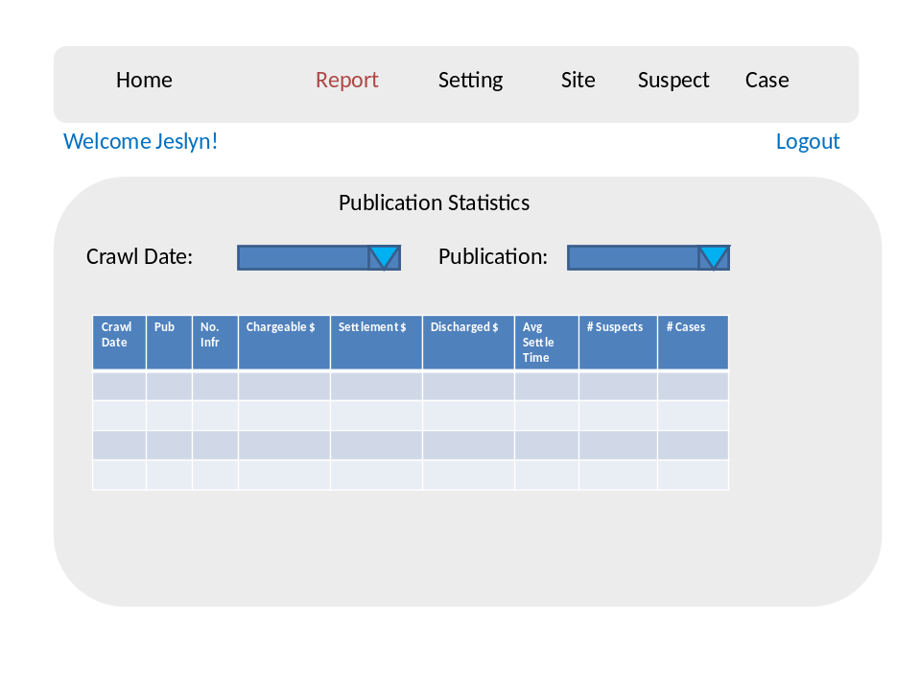
- Case Summary Statistics is shown below.
- Select a specific crawled schedule to view a report.
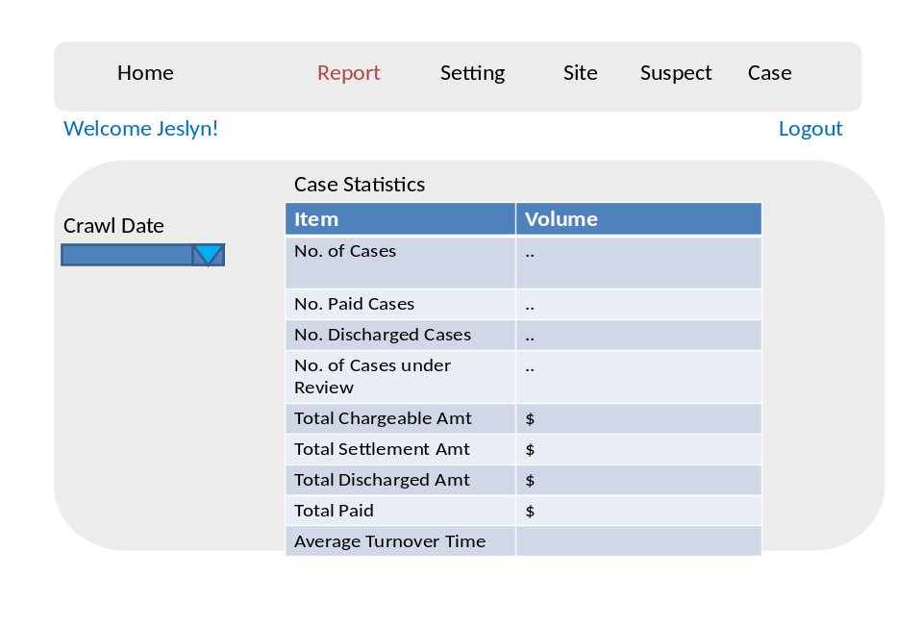

Site Info
- Click the button ‘Site’ to create or manage an existing site.
- To manage a site, input or select the specific fields, then click the button ‘Search’ to find a site.
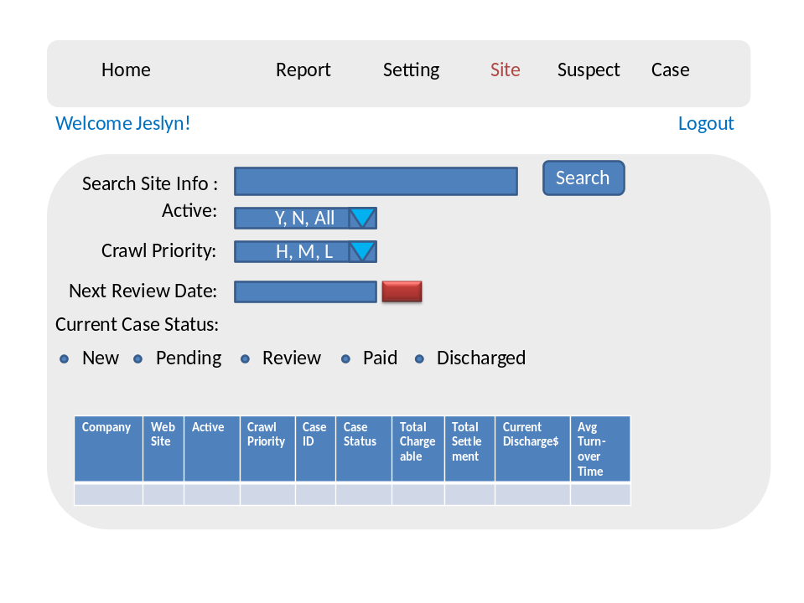
- Click a site from above table to view, edit and delete a site information.
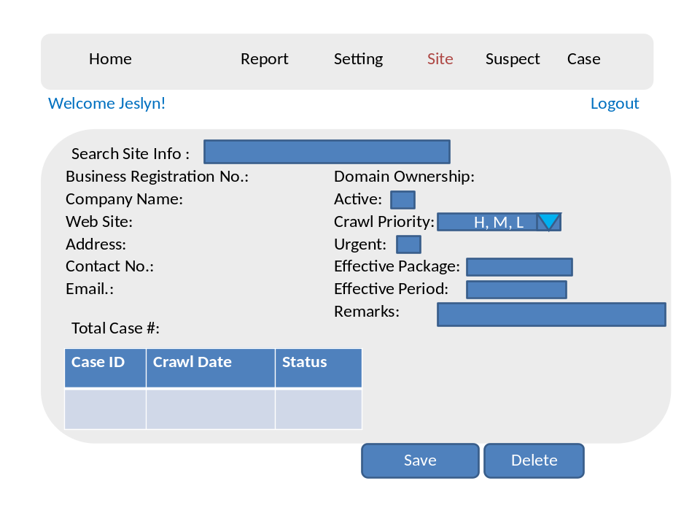
- Click the button ‘Save’ to save site information.
- Click the button ‘Delete’ to delete site information from seed list.

- To create a new site information, input the fields, then click the button ‘Save’
To save all entered data.
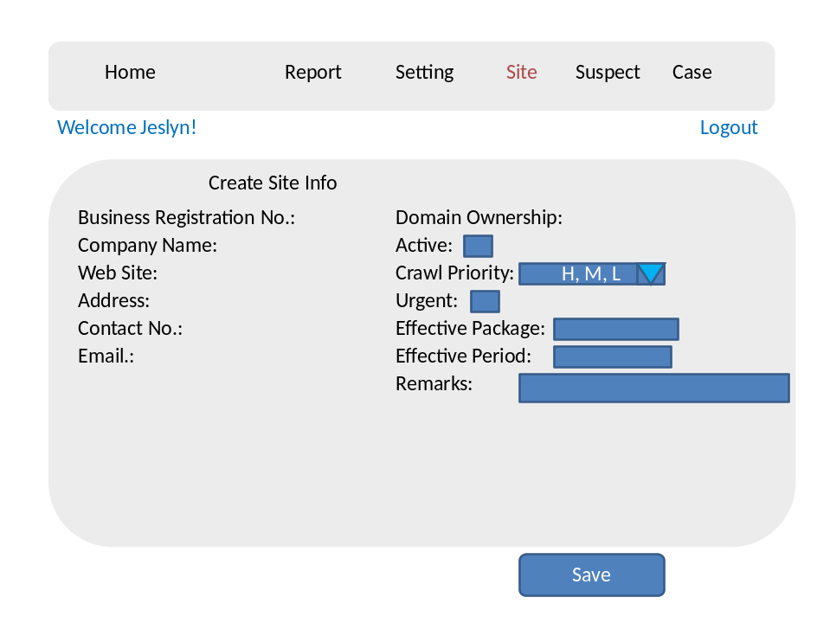

Settings
- Click button ‘Setting’ on the menu to view and edit the global parameters, which can be used for the entire system. Click on the “Save” button to save entered information.
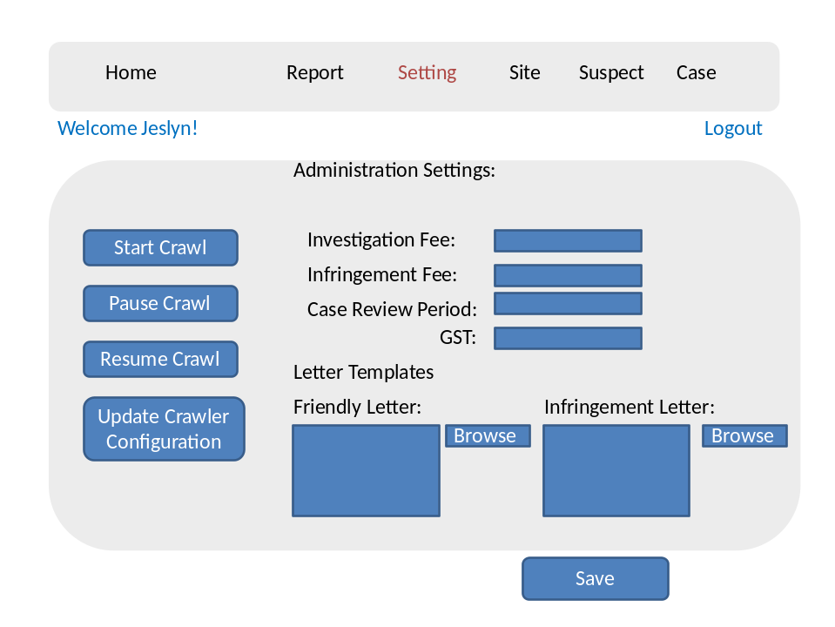

Reference

ID or Reference Number | Title | Comments
Version 1.0 | SOW SPH IP Tracking

